Ansible: Multi-Playbook YAML and Execution Methods

1. Multi-Playbook in One YAML File
You can include multiple plays in a single YAML file, each targeting different host groups or performing separate tasks.
Example:
- name: Install Apache on web servers
hosts: web
become: true
tasks:
- name: Install httpd
yum:
name: httpd
state: present
- name: Install MariaDB on db servers
hosts: db
become: true
tasks:
- name: Install MariaDB
yum:
name: mariadb-server
state: present
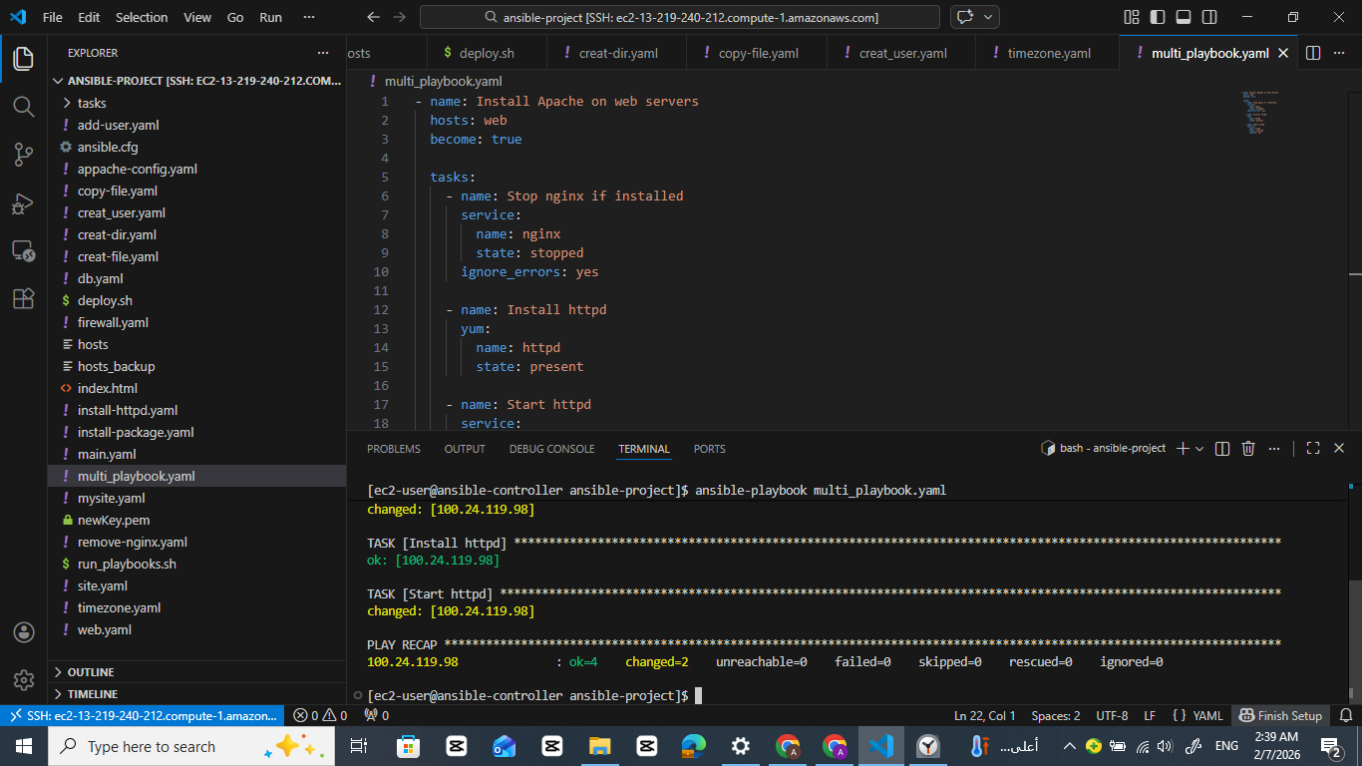

2. Methods to Run Multiple Playbooks in One Command
Option 1: Combine Plays in a Single File
You can include all plays in one `.yml` file as shown above and run it once:
ansible-playbook site.yml
Option 2: Use Tags
Assign tags to different plays or tasks and use --tags to selectively run parts of the playbook.
Option 3: Shell Script
Create a shell script to run multiple playbooks sequentially:
#!/bin/bash
ansible-playbook web.yml
ansible-playbook db.yml
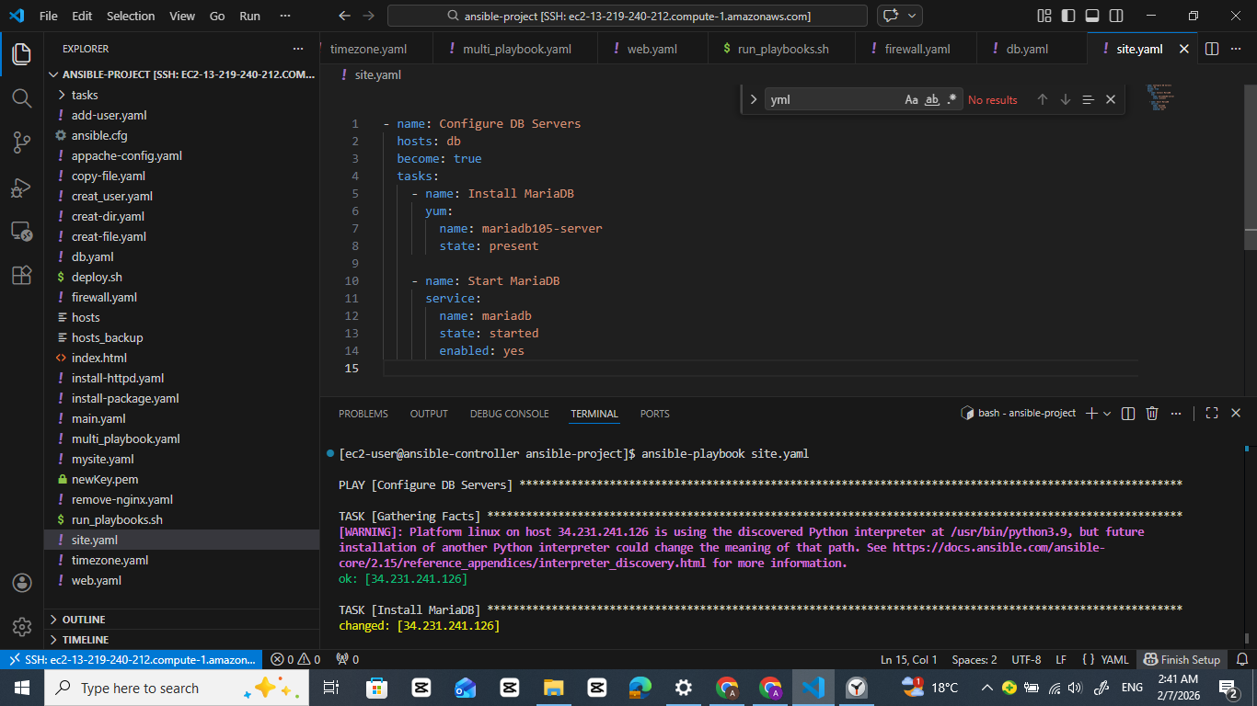
2
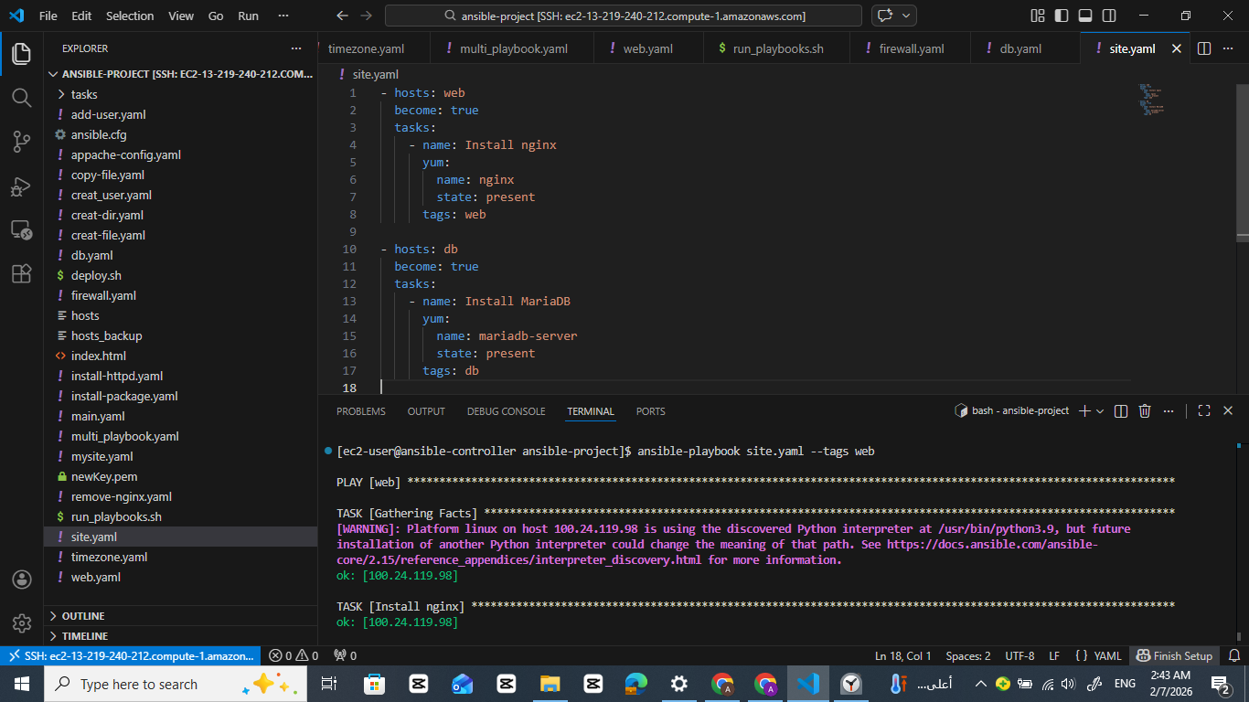
3
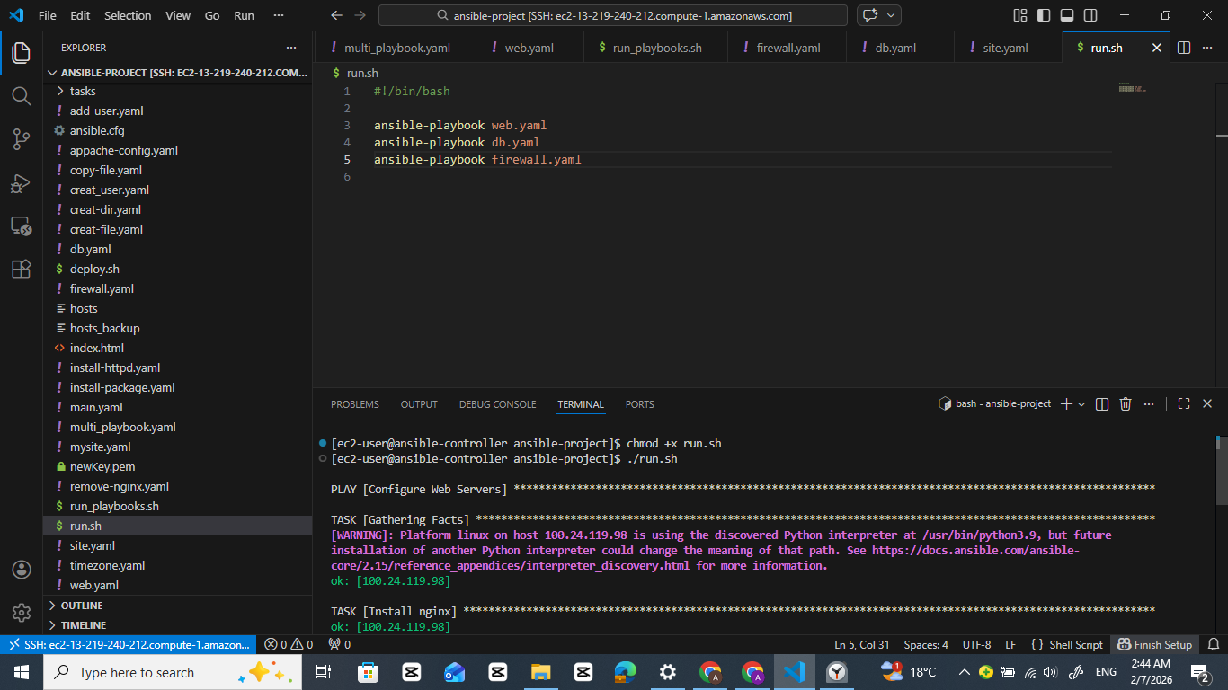

3. import_playbook: Static Include
Use this when you want to statically include another playbook. It behaves as if the content of the imported playbook is copied into the main one at runtime.
📄 site.yml
- import_playbook: web.yml
- import_playbook: db.yml
Then run:
ansible-playbook site.yml
This will sequentially run web.yml, then db.yml.
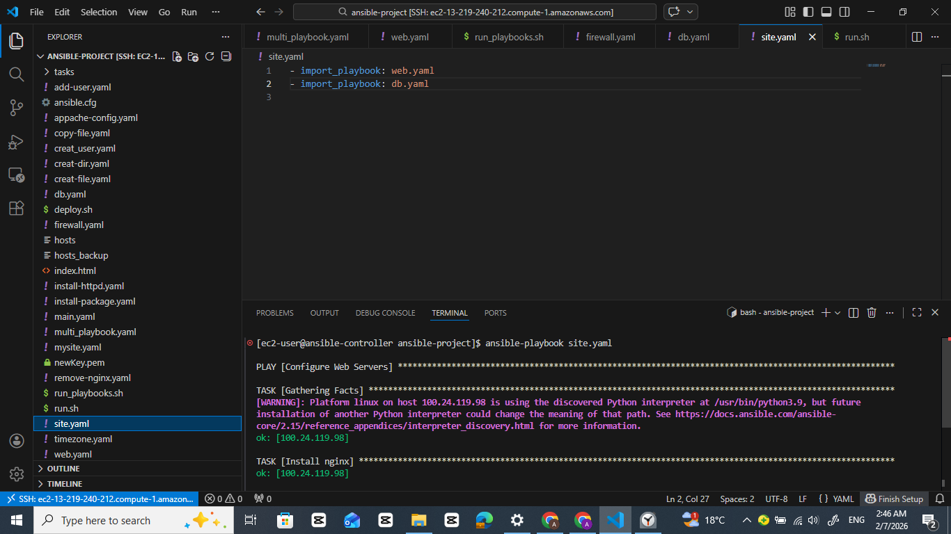

4. include_tasks: Dynamic Include in a Play
Use when you're inside a task list and want to include a task file (not a full playbook):
📄 main.yml
- name: Common Setup
hosts: all
become: true
tasks:
- name: Include web tasks
include_tasks: web-tasks.yml

- name: Include db tasks
include_tasks: db-tasks.yml
📄 web-tasks.yml
- name: Install nginx
yum:
name: nginx
state: present
📄 db-tasks.yml
- name: Install mariadb
yum:
name: mariadb-server
state: present

5. Tags to Organize and Run Selectively
📄 site.yml
- name: Web tasks
hosts: web
become: true
tasks:
- name: Install nginx
yum:
name: nginx
state: present
tags: web

- name: DB tasks
hosts: db
become: true
tasks:
- name: Install mariadb
yum:
name: mariadb-server
state: present
tags: db
Run only one section:
ansible-playbook site.yml --tags web

7. Run Multiple Playbooks in One Line
Using && in the shell:
ansible-playbook web.yml && ansible-playbook db.yml && ansible-playbook app.yml

